**CFD ANALYSIS FOR LAYOUT OPTIMIZATION OF FLUE GAS DUCTING BETWEEN AIR PRE HEATER AND ELECTROSTATIC PRECIPITATOR**

*A PROJECT REPORT*

*submitted by*

S.JEANAUSTIN (118132003)

*towards partial fulfillment of the requirements for the award of the degree*

*of*

Master of Technology in Thermal Engineering



**School of Mechanical Engineering**

**SASTRA DEEMED TO BE UNIVERSITY**

(A University established under section 3 of the UGC Act, 1956)

Tirumalaisamudram-613 401

**MAY 2018**

**BONAFIDE CERTIFICATE**

This is to certify that the project work entitled “**CFD ANALYSIS FOR LAYOUT OPTIMIZATION OF FLUE GAS DUCTING BETWEEN AIR PRE HEATER AND ELECTROSTATIC PRECIPITATOR**” is a bonafide record of the work carried out by

S.JEANAUSTIN (118132003)

student of M.Tech., Thermal Engineering, in partial fulfillment of the requirements for the award of the degree of M.Tech in Thermal Engineering of the **SASTRA DEEMED UNIVERSITY, Tirumalaisamudram, Thanjavur - 613401**, during the year 2017-2018.

**NAME OF THE INTERNAL GUIDE:** Dr. T.Mohanraj, SASTRA University, Thanjavur.

**NAME OF THE EXTERNAL GUIDE:** Dr. Avvari Ramesh, BHEL Trichy.

**SIGNATURE SIGNATURE**

**(Internal guide)**  **(External guide)**

**Project Viva-voce held on _____________________________**

**Internal Examiner External Examiner**

**Acknowledgment**

I would like to express my sincere gratitude to **Prof. R. Sethuraman**, Vice-Chancellor, SASTRA Deemed to be University and The Registrar, **Dr.K.Sridharan**, to permit me to successfully complete this project work in the university.

I would like to express my sincere gratitude to **Mr. S. Thiagarajan**, AGM, Product Engineering, and **Mr. A. M. Arul Anban**, HR Manager, BHEL, Trichy to permit me to successfully complete this project work in the company.

I wish to convey my sincere gratitude to **Dr. S. Pugazhenthi**, Dean, School of Mechanical Engineering, SASTRA Deemed to be University, for his support towards the completion of this project. I would like to thank my Internal Guide, **Dr.T.Mohanraj**, Senior Asst. Professor, SASTRA Deemed to be University and my External Guide, **Dr. Avvari Ramesh**, Senior manager, Layouts (RPD)/PE (FB), BHEL, for their constant motivation, guidance and support in the duration of the project.

I am grateful to express my sincere thanks to **Shri.D.VENKATESAN**, Assistant Professor, School of Mechanical Engineering, SASTRA Deemed to be University for his suggestions and encouragement during the project review process.

I would also like to thank Apprentice students of BHEL for his help in designing, analysing the results from the simulations and preparation of the thesis report.

I would like to thank Almighty god, my parents and friends for their guidance and support to complete the Project.

**TABLE OF CONTENTS**

**Page Number**

ACKNOWLEDGEMENT iii

ABSTRACT vi

LIST OF TABLES vii

LIST OF FIGURES viii

NOTATIONS xi

**CHAPTER 1 INTRODUCTION**

1.1 History of Flue gas Ducting 1

1.2 Air Pre-Heater 2

1.3 Electro Static Precipitator 3

1.4 Scope of Current Work 3

**CHAPTER 2 LITERATURE REVIEW** 4

**CHAPTER 3 COMPUTATIONAL DETAILS**

3.1 Computational Fluid Dynamics (CFD) 8

3.2 Governing Equations 8

3.2.1 Continuity Equation 8

3.2.2 Momentum Conservation Equation 9

3.2.3 Energy Conservation Equation 9

3.3 k-ε Turbulence Model Equation 10

3.3.1 k- Equation 10

3.3.2 ε- Equation 10

3.4 3D Model of a Duct from Air Preheater

to Electrostatic Precipitator 11

3.5 Geometrical calculation of 3D model duct 15

3.6 Mesh Generation and Boundary Conditions 17

3.7 Analysis of Velocity zones 19

**CHAPTER 4 RESULTS AND DISCUSSION**

4.1 Actual duct System 20

4.2 Ducting System with Guide vanes 23

4.3 Ducting System with Guide Plate according to

angle variation by NG method 26

4.4 Analysis of Variation in Percentage Deviation

of Mass flow rate 33

4.5 Analysis of Variation in Pressure Drop 35

4.6 Analysis of Variation in Percentage

Deviation of Velocity 36

4.7 Analysis of Percentage Deviation

in flow rates in ESP streams 38

**CHAPTER 5 CONCLUSION** 40

**REFERENCES**

**ABSTRACT**

Sudden change in the flow direction are quite common in layout of flue gas ducting between air preheater and electrostatic precipitator. The most economical solution of optimization of ducting problem reduces the pressure drop in the duct and enables higher flow at reduced pressure drop and is achieved by inclusion of guide vanes and guide plates. Also the flue gas in Air preheater (APH) to Electrostatic precipitator (ESP) duct causes higher pressure drop, flow mal-distribution among ESP passes, turbulence, erosion leakages and reverse flow in bends, connecting and branched outlet ducts. The flue gas carries ash particles which under operating conditions hit the duct walls and can cause erosion of guide vanes or duct walls. The turbulence caused due to sharp turns and sudden changes in the duct geometry results in noise and vibration. The pressure drop occurs due to reverse flow of flue gas in a duct. In order to reduce the problems that we can use different approaches like shape changing, Area reduction, Application of guide vanes and guide plates using CFD software. The pressure and velocity readings are taken for before and after modifications cases and comparison are done. The optimized iterations can be found out by guide plates angle variation using increasing or decreasing of corresponding guide plate according to the deviation of ESP stream flow from the desired average value.

**Keywords:** CFD, Flue gas, Ducting, Pressure drop, Velocity

**LIST OF TABLES**

Table 3.1 Boundary Conditions for a ducting system 18

Table 4.1 Analysis of percentage deviation in mass flow rate 34

Table 4.2 Analysis of Pressure drop in each zone for each cases 36

Table 4.3 Analysis of percentage deviation in Velocity 37

Table 4.4 Analysis of percentage deviation of Flow rates

in ESP streams 38

**LIST OF FIGURES**

Fig 3.1 3D model for base duct 11

Fig 3.2 3D model of Duct with Guide vanes 12

Fig 3.3 3D model of Duct with Guide Plates 13

Fig 3.4 3D model of Duct with Guide Plates at

the angles Ө1=45°, Ө2 =135°, Ө3=155° 14

Fig 3.5 3D model of Duct with Guide Plates at

the angles Ө1=45°, Ө2 =145°, Ө3=135° 14

Fig 3.6 3D model of Duct with guide Plate at

the angles Ө1=60°, Ө2 =145°, Ө3=135° 15

Fig 3.7 Meshing of a 3D Duct in GAMBIT 18

Fig 4.1 Contours of Static Pressure for base duct 20

Fig 4.2 Contours of Velocity magnitude for base duct 21

Fig 4.3 High velocity zones in Base duct 22

Fig 4.4 Low velocity zone in base duct 22

Fig 4.5 Pressure Contours of Duct with Guide vanes 23

Fig 4.6 Velocity Contours of Duct with Guide vanes 24

Fig 4.7 High Velocity Zones of duct with guide vanes 25

Fig 4.8 Low Velocity Zones of duct with guide vanes 25

Fig 4.9 Pressure Contours of Duct with Guide Plate

at the angles Ө1=45°,Ө2 =135°, Ө3=155° 26

Fig 4.10 Velocity Contours of Duct with Guide Plate

at the angles Ө1=45°,Ө2 =135°, Ө3=155° 27

Fig 4.11 High Velocity Zone of Duct with Guide Plate

at the angles Ө1=45°,Ө2 =135°, Ө3=155° 27

Fig 4.12 Low velocity zone of Duct with Guide Plate

at the angles Ө1=45°,Ө2 =135°, Ө3=155° 28

Fig 4.13 Pressure contours of the ducts with guide plates

at an angle Ө1=45°, Ө2 =145°, Ө3=135° 29

Fig 4.14 Velocity contours of the ducts with guide plates

at an angle Ө1=45°, Ө2 =145°, Ө3=135° 29

Fig 4.15 High Velocity Zone with guide plates

at an angle Ө1=45°, Ө2 =145°, Ө3=135° 30

Fig 4.16 Low Velocity Zone with guide plates

at an angle Ө1=45°, Ө2 =145°, Ө3=135° 30

Fig 4.17 Pressure contours of the ducts with guide plates

at an angle Ө1=60°, Ө2 =145°, Ө3=135° 31

Fig 4.18 Velocity contours of the ducts with guide plates at

an angle Ө1=60°,Ө2 =145°, Ө3=135° 32

Fig 4.19 High Velocity Zone with guide plates at

an angle Ө1=60°, Ө2 =145°, Ө3=135° 32

Fig 4.20 Low Velocity Zone with guide plates at

an angle Ө1=60°, Ө2 =145°, Ө3=135° 33

Fig 4.21 Graph of % deviation in Mass flow rate 34

Fig 4.22 Graph of variation in Pressure drop 35

Fig 4.23 Graph of % deviation in Average velocity 36

Fig 4.24 Graph of % deviation of flow rates in ESP streams 38

**NOTATIONS**

BMCR Boiler Maximum Critical Rating

TMCR Turbine Maximum Critical Rating

GV Guide Vane

GP Guide plate

ESP Electrostatic Precipitator

ΔP Pressure Drop

x Axial Co-ordinate

y Co-ordinate perpendicular to Outlet Area

z Tangential Co-ordinate

fx Molar Fraction in x-direction of the duct

fy Molar Fraction in y-direction of the duct

fz Molar Fraction in z-direction of the duct

V Volume of flow rate of duct

T Temperature of flue gas

E Energy constant

Turbulence volume Flow rate of flue gas

k Turbulence kinetic Energy

Drag Coefficient

Mean Distance between flow particles

Flow Velocity

P Absolute Pressure

li Length of the inlet zone

bi Width of the inlet zone

mi Mass Flow rate at inlet Zone

Ain Area of Inlet zone

Pin Perimeter of Inlet zone

Qin Flow rate at inlet zone

Dhi Hydraulic Diameter at Inlet zone

Vin Inlet zone Velocity

Lo Length of the outlet zone

bo Width of the outlet zone

mo Mass Flow rate at outlet zone

Aout Area of Outlet zone

Pout Perimeter of outlet zone

Qout Flow rate at Outlet zone

Dho Hydraulic Diameter at outlet zone

Vout Outlet zone Velocity

Darc Arc Diameter

Lext Length of Extrusion

AGV2 Area of Guide Vane 2

LGP1 Length of Guide Plate 1

**Greek Letter**

Turbulence Viscosity

Ρ Density of flue gas

Shear Stress tensor in x-x direction

Shear Stress tensor in y-x direction

Shear Stress tensor in z-x direction

Shear Stress tensor in y-y direction

Shear Stress tensor in x-y direction

Shear Stress tensor in z-z direction

Effective viscosity of flue gas

Absolute Errors in flow directions

Standard Deviation of Particle in fluctuation

Empirical Constant=1.44

Ө Angle of Guide Plates

**CHAPTER 1**

**INTRODUCTION**

Flue gas ducting in a high Pressure boiler plant will connect different equipment like Boiler furnace and pressure part zone, Selective catalytic reactor (SCR), Air preheater, Electrostatic precipitator (ESP), Flue gas desulphurisation (FGD), ID fan and Chimney through which hot flue gas is conveyed along with ash after combustion in furnace. The purpose of duct designing is to achieve good reliable plant operation by minimizing a pressure drop in the flue gas passing between air preheater and ESP and also to equally distribute the flue gas to all ESP streams for proper ash collection. The system pressure loss varies depending upon what pollution control equipment is used and how the equipment is used and ducts are designed to handle the gas flow. In this project k-ε turbulence models with Standard wall functions and Newton Raphson iterative method for angle and mass flow rate variation are used. The analysis has been carried out for both 50% TMCR and 100% BMCR design fuel at boiler matching section. Many journals describe that the shape optimization has been done using MATLAB, GAMBIT and ANSYS Fluent. In this project, we are going to analyse and optimize the flow of flue gas in Air Pre-Heater to Electro-Static Precipitator (ESP) inlet duct using GAMBIT 2.4.6 and ANSYS 16 Fluent software for pressure drop reduction by applying guide vanes and guide plates with its angle variations.

* 1. **History of flue gas Ducting**

A flue is a [duct](https://en.wikipedia.org/wiki/Duct_(HVAC)), [pipe](https://en.wikipedia.org/wiki/Pipe_(material)), or opening in a [chimney](https://en.wikipedia.org/wiki/Chimney) for conveying [exhaust gases](https://en.wikipedia.org/wiki/Exhaust_gas) from a [fireplace](https://en.wikipedia.org/wiki/Fireplace), [furnace](https://en.wikipedia.org/wiki/Furnace), [water heater](https://en.wikipedia.org/wiki/Water_heater), [boiler](https://en.wikipedia.org/wiki/Boiler), or [generator](https://en.wikipedia.org/wiki/Electrical_generator) to the outdoors. Historically the term flue meant the chimney itself. In the United States, they are also known as vents for boilers and as breeching for water heaters and modern furnaces. They usually operate by [buoyancy](https://en.wikipedia.org/wiki/Buoyancy), also known as the [stack effect](https://en.wikipedia.org/wiki/Stack_effect), or the combustion products may be 'induced' via a [blower](https://en.wikipedia.org/wiki/Fan_(mechanical)). As combustion products contain [carbon monoxide](https://en.wikipedia.org/wiki/Carbon_monoxide) and other dangerous compounds, proper 'draft', and admission of replacement air is imperative. [Boiler design codes](https://en.wikipedia.org/wiki/Building_code), and other standards, regulate their materials, design, and installation.

**1.2 Air Preheater**

An air preheater (APH) is any device designed to heat [air](https://en.wikipedia.org/wiki/Air) before another process (for example, [combustion](https://en.wikipedia.org/wiki/Combustion) in a [boiler](https://en.wikipedia.org/wiki/Boiler)) with the primary objective of increasing the thermal efficiency of the process. They may be used alone or to replace a [recuperative](https://en.wikipedia.org/wiki/Recuperator) heat system or to replace a steam coil.

In particular, this article describes the combustion air preheaters used in large [boilers](https://en.wikipedia.org/wiki/Boilers) found in [thermal power stations](https://en.wikipedia.org/wiki/Thermal_power_station) producing [electric power](https://en.wikipedia.org/wiki/Electric_power) from e.g. [fossil fuels](https://en.wikipedia.org/wiki/Fossil_fuel_power_plant), [biomass](https://en.wikipedia.org/wiki/Biomass) or [waste](https://en.wikipedia.org/wiki/Incinerator).

The purpose of the air preheater is to recover the heat from the boiler [flue gas](https://en.wikipedia.org/wiki/Flue_gas) which increases the thermal efficiency of the boiler by reducing the useful heat lost in the flue gas. As a consequence, the flue gases are also conveyed to the [flue gas stack](https://en.wikipedia.org/wiki/Flue_gas_stack) (or [chimney](https://en.wikipedia.org/wiki/Chimney)) at a lower temperature, allowing simplified design of the conveyance system and the flue gas stack. It also allows control over the temperature of gases leaving the stack (to meet emissions regulations, for example).It is installed between the economizer and chimney.

**1.3 Electro-static Precipitator**

An [electrostatic precipitator](https://en.wikipedia.org/wiki/Electrostatic_precipitator) (ESP) is a filtration device that removes fine particles, like dust and smoke, from a flowing gas using the force of an induced [electrostatic charge](https://en.wikipedia.org/wiki/Electrostatic_charge) minimally impeding the flow of gases through the unit. In contrast to [wet scrubbers](https://en.wikipedia.org/wiki/Wet_scrubber) which apply energy directly to the flowing fluid medium, an ESP applies energy only to the particulate matter being collected and therefore is very efficient in its consumption of energy (in the form of electricity).

The first use of [corona discharge](https://en.wikipedia.org/wiki/Corona_discharge) to remove particles from an aerosol was by Hohlfeld in 1824. However, it was not commercialized until almost a century later.

In 1907 [Frederick Gardner Cottrell](https://en.wikipedia.org/wiki/Frederick_Gardner_Cottrell), a professor of chemistry at the [University of California, Berkeley](https://en.wikipedia.org/wiki/University_of_California,_Berkeley), applied for a patent on a device for charging particles and then collecting them through [electrostatic](https://en.wikipedia.org/wiki/Electrostatic) attraction—the first [electrostatic precipitator](https://en.wikipedia.org/wiki/Electrostatic_precipitator). Cottrell first applied the device to the collection of [sulphuric acid](https://en.wikipedia.org/wiki/Sulfuric_acid) mist and [lead oxide](https://en.wikipedia.org/wiki/Lead_oxide) fumes emitted from various acid-making and [smelting](https://en.wikipedia.org/wiki/Smelting) activities. Wine-producing [vineyards](https://en.wikipedia.org/wiki/Vineyards) in northern California were being adversely affected by the lead emissions.

**1.4 Scope of current Work**

The duct which carries the flue gas between Air preheater and Electro-Static Precipitator is analysed. The aim of the current work is to analyse and reduce the pressure drop in the duct between Air Preheater and ESP and also to supply equal flow in all stream of ESP within ±10% deviation. The uniform flow has been made across the cross section and excess velocity, very low velocities and also recirculation zones have been removed by using guide vanes and guide plates.

**CHAPTER 2**

**LITERATURE SURVY**

The analysis and optimization of flue gas ducting has been a popular subject for researchers in Energy engineering and other related topics like Thermal and Chemical Engineering. Presented below is the review of existing literature related to Electrostatic precipitator and flue gas ducting shape optimization.

Madhulika singh etal. [1] approached to Design and optimization of air, Flue gas, Ducting System to improve the ducting layout and reduce the pressure drop by using CFX ANSYS tool for improvement of efficiency. He also drawn the 3D model using Design modeller and Computed in ANSYS CFX Software.

Shah M.E .Haque etal. [2] has presented the study of influence of Velocity profile at inlet boundary on the simulation of velocity distribution inside the ESP of a power plant and other process industry. The model has been developed deals with the air flow through lab scale ESP before introducing any electrostatic forces. It is suggested for the industrial application, that experimentally measured velocity distribution should be used at inlet boundary for accurate and realistic flow simulation.

M.G .Rasul etal. [3] has simulated the flow in an electrostatic precipitator of a thermal power plant by numerically by using CFD techniques and also by using k-ε turbulence model and Navier Stokes equation. The detailed numerical approach and simulation procedure is displayed to predict the flow behaviour inside ESP which its results are compared to one side measured data. The flow model developed has the potential to better predict the effect of possible modifications and ESP design improvement. The Numerical computation of fluid flow properties can be analysed by using fluent solver.

F.J.Guttierrez Ortiz etal. [4] has been described about the Dry sorbent injection technology offers a more economical technology for retrofitting than wet or semi-wet scrubbling process. The Calcium sulphate fraction is oxidized to gypsum is done in the reaction. This process occurs in pilot plant which is at 550MW capacity in Spain. The duct desulphurisation process is to develop and verify a simple realistic model for the process and also comparing model results and experimental data obtained from pilot plant. Here the SO2 removal process is done by mass balance and energy balance simulation has been done using VISUAL BASIC 5.0.

Ramesh Avvari etal. [5] has analysed the flow appointment algorithm for optimization power plant in ducting the process has been done for a 2D geometry and requires more than 200 CFD computations arrive at optimal guide plate locations. The analysis has been done by placing the guide plates with various angles in outlets of the duct to obstruct the flow. The optimization has been done by shape changing method and NG method has been used for setting guide vane angle. The numerical solutions has been done by Jacobian iteration method and recursion method.

Ramesh Avvari etal. [6] has optimized the heuristic shapes of gas ducting process in power plants for the change of flow direction. Here the flow is typically 90o square bend which is inertial forces and centrifugal forces due to the complex swirling flow develops in bend portion. Here the iterations are done for 90o square bend for two successive iterations and also the iterations have been done by changing the shape of duct by velocity variation from 0 to 0.9m/s, the successive iterations of the optimization procedure for a square bend with Reynolds number of 50000. The evolution of pressure drop and average displacement of vertices of control lines are varies according to iterations. The graphical relations of bend pressure drop and with iteration and also volumetric flow rate lags behind pressure drop across bend has been done.

V.B.Gawande etal. [7] has analysed the flow of flue gas in Electrostatic Precipitator at thermal power plant where the flue gases are transported from boiler to Air Pre-Heater (APH) later it goes to ESP (Electro-Static Precipitator) which has ash particles. It has the main objective to design turning vanes and modifying duct layout in order to reduce pressure drop turbulent and minimize the erosion of duct walls are caused due to high velocity. The flow is analysed to investigate the flow behaviour ducts and reducing pressure through the system. To achieve this the developed model has been simulated the flow of flue gas through duct. It has been done by reducing velocity from 15m/s to 12m/s.

C. Bhaskar [8] has been describes about simulation of flow in Electrostatic Precipitator ducts with guide vanes which is used in the electric utility industry for removing particles from flue gas generated coal fired boilers. The physical modelling of this ducts has been done using 3D CAD Model and meshing of it has been done using GAMBIT software and exported to FLUENT, CFX and Star-D. The rate of flow is identified by analyse of velocity contours.

A.S.M. Sayem etal. [9] analysed the flow distribution in an Electro Static Precipitator of coal burned power plant by using baffles. The coal has been used as the major source. The ESP is one of the most reliable and industrially controlled devices to capture the fine particles for reducing emission. It has 99% efficiency. This process uses a number of baffles in a duct to increase the residence time of exhaust. The numerical simulations behaviour has been analysed by ANSYS fluent flow and also structured mesh has been created.

Laszlo Czetany etal. [10] has been analysed the model of rectangular supply duct with variation cross section that provides air distribution. The simple theoretical model is suggested, with which it is possible to design ventilation ducts that are capable of uniform distribution on the outlets. The design of duct system is well established for special cases for which other methods can lead to better results. Distribution ducts or pipes were investigated by many researchers and topics have long history. The 1D theoretical model has been used to determine the optimal duct geometry for different values of characteristic dimensionless variables and measurement has been conducted for validation of model. The Colebrook-white equation and original Momentum Equation.

Luca morocco etal. [11] has been prescribed the dry sorbent injection process which used to control the sulphuric acid (SO2) by injection power alkaline sorbent (Hydrated lime) into flue gas system. CFD coupled with appropriate SO2 model of absorption which acts as a powerful tool in design and analysis of dry scrubbling system as previously done for wet flue gas desulphurization (WGFD) equipment. The numerical analysis has been done using dispersed volume fraction, continuity momentum and species conservation equation and also mixing efficiency has been calculated.

**CHAPTER 3**

**COMPUTATIONAL DETAILS**

**3.1 Computational Fluid Dynamics (CFD)**

Computational Fluid Dynamics or CFD is the technique of solving fluid flow and heat transfer problems using computational or numerical methods. It is a known fact that any fluid flow is governed by continuity and momentum conservation equation. For phenomena involving a temperature gradient, energy equation is also to be solved along with the continuity and momentum conservation equation. The method of solving these governing equations using numerical methods is known as Computational Fluid Dynamics. The governing equations of fluid flow will be discussed in coming sections.

**3.2 Governing Equations**

**3.2.1 Continuity Equation**

Continuity equation represents the law of conservation of mass in mathematical form. The law states that mass can neither be created nor destroyed. This equation can be represented in a differential form as

This equation is the compressible form of continuity equation. In this work, density is assumed to change with temperature and ideal gas law is used to define density.

**3.2.2 Momentum Conservation Equation**

The momentum conservation equation is another form of Newton’s Second law of motion which says that momentum is always conserved. This equation was discovered independently by Navier and Stokes and is therefore known as the Navier-Stokes Equation. This equation is represented as three equations, in x, y and z directions, since momentum is a vector. These equations are as below

**3.2.3 Energy Conservation Equation**

The energy equation is obtained from the law of conservation of energy which states that energy can neither be created or destroyed but can only be transformed from one form to another. This equation can be given as

**3.3 k-ε Turbulence Model Equation**

The k − ε model was first proposed by Jones and Launder. It is now consider the standard turbulence model for engineering simulation of flows. The modified Boussinesq eddy viscosity model overcomes the first problem of the mixing length hypothesis, viz. that µt is not defined in regions of zero shear (∂U/∂y = 0). To relate µt to the Reynolds stresses, and assume that

So that

Where C is a constant. Using this model µt is nonzero everywhere in the flow that k is nonzero. The new independent variables of the turbulence model are lm and k.

**3.3.1 k -Equation**

The k Equation An exact equation for k is obtained by taking the inner product of the velocity vector and the momentum equation (in vector form). The result after some algebra is a conservation equation for k is

**3.3.2 ε-Equation**

Like the Reynolds averaged equations this equation also has higher order correlations. The solution is to model these correlations. The standard form of the model is

**3.4 3D Model of a Duct from Air Preheater to Electrostatic Precipitator**

The 3D model of duct has been created by using AUTODESK Inventor Software. The 3D model for base duct is shown in Fig 3.1. It is a Duct which contains Air Pre-Heater is situated front and middle two flue gas flow branches are situated. One flow branch is near inlet zone and another flow branch is before Outlet zones.

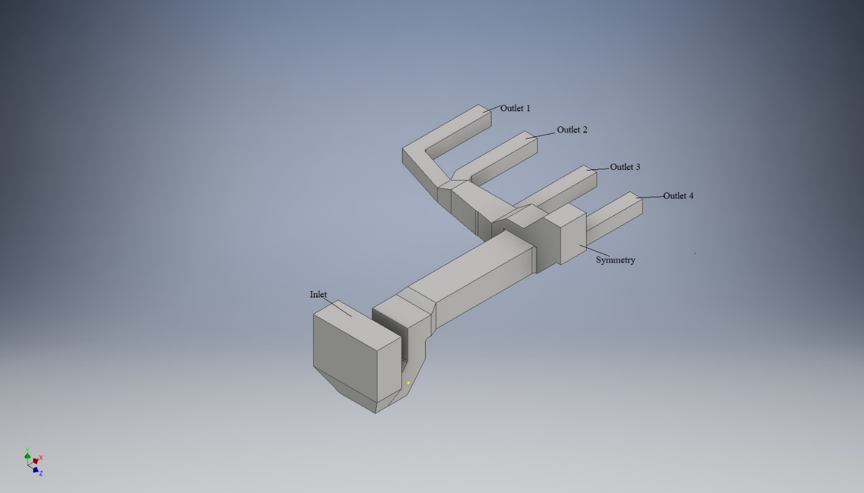

Fig 3.1 3D model for base duct

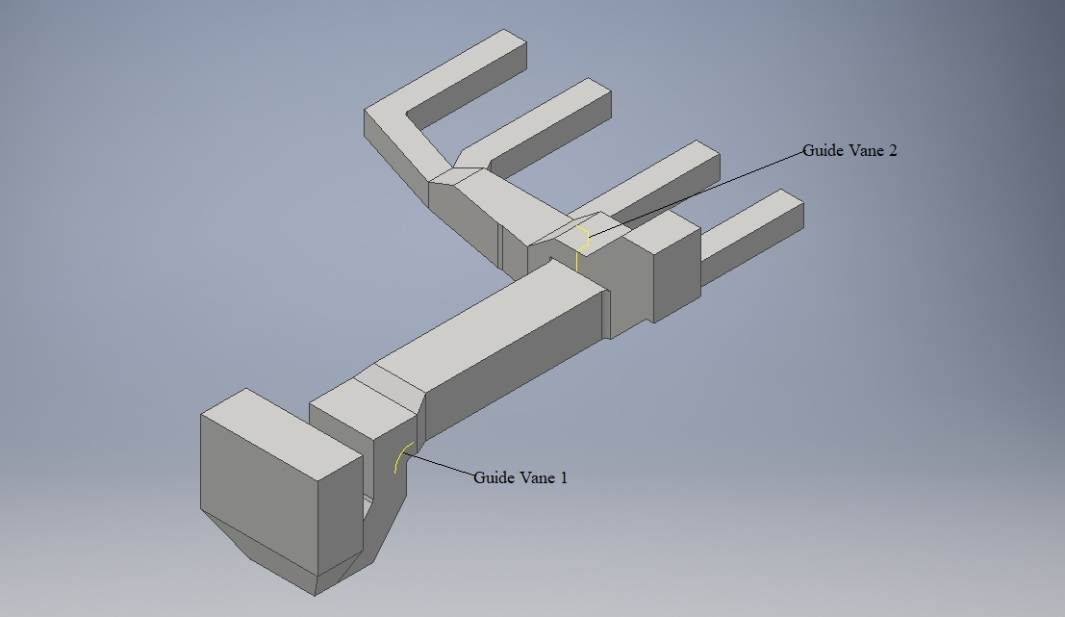

Fig 3.2 3D model of Duct with Guide vanes

The 3D model for base duct with guide vanes is shown in Fig 3.2. The Guide vanes are shown in the bent branch near inlet zone and vertical branch near outlet zones. The curved guide vane is near the inlet zone and bent guide vane near outlet zone.

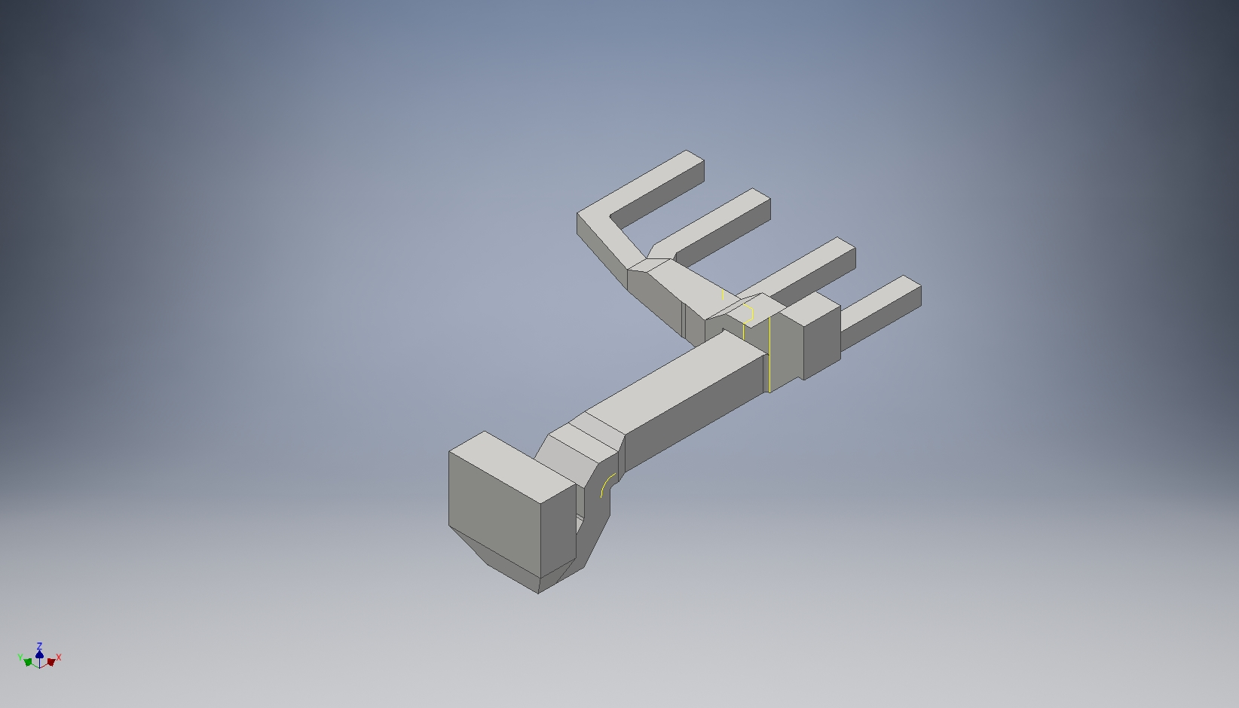

Fig 3.3 3D model of Duct with Guide Plates

The 3D model for base duct with Guide Plate added is shown in Fig 3.3. The Guide Plates are added near the Branch duct, near Symmetry Outlet zone pipe and third Outlet zone pipe to obstruct the heavy flow to make the flow constant. The duct is chamfered near the inlet.

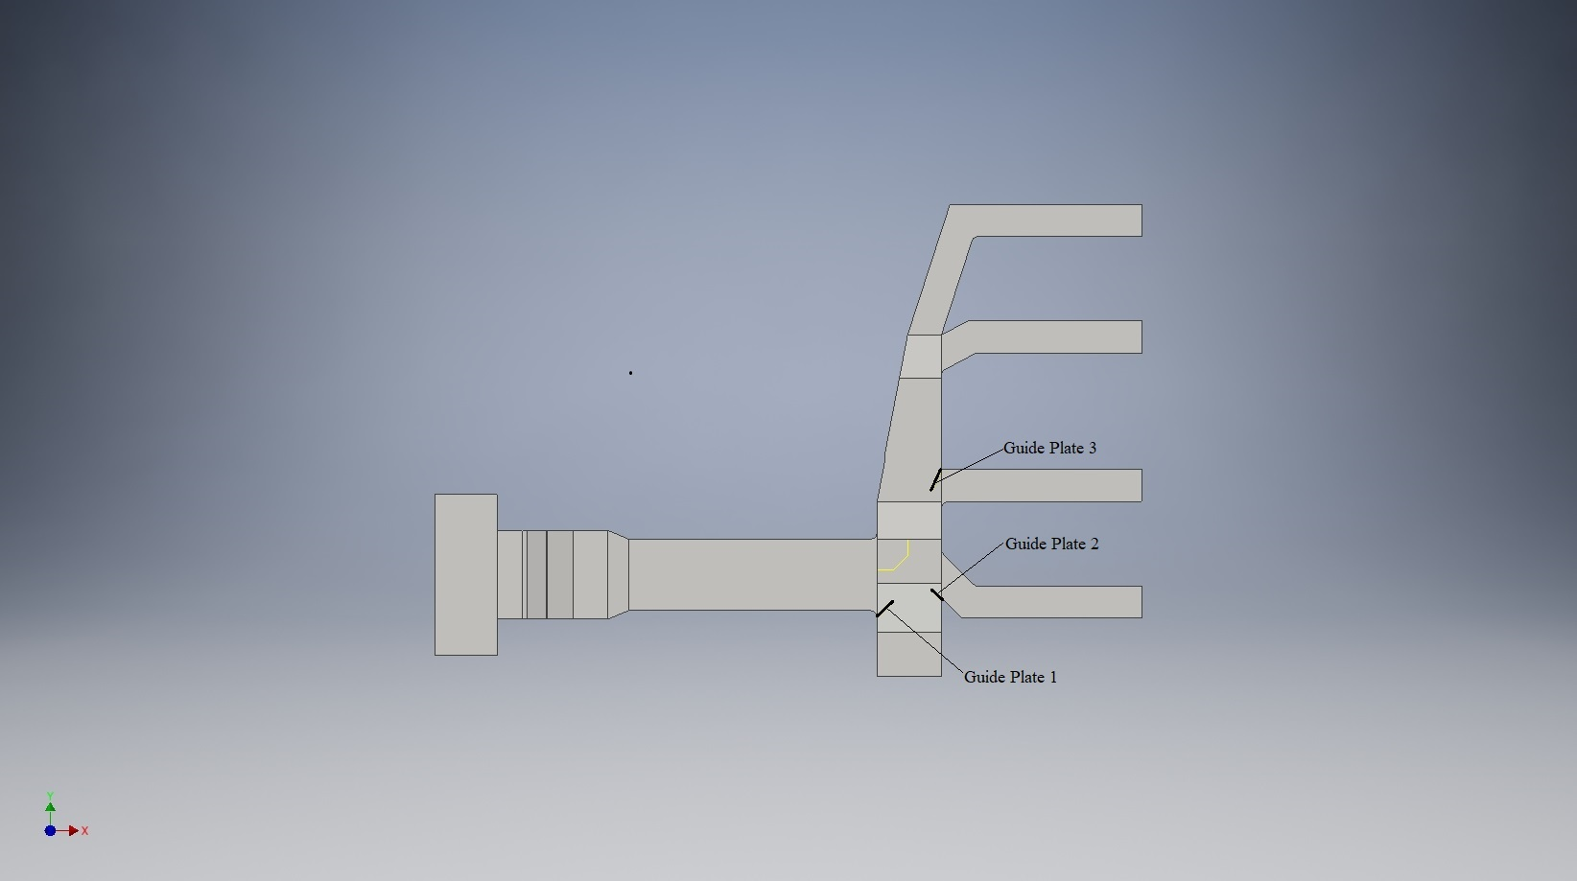

Fig 3.4 3D model of Duct with Guide Plate at the angles Ө1=45°,Ө2 =135°, Ө3=155°

The 3D model for base duct with Guide Plate with 3D model of Duct with Guide Plates at angle of Guide Plate at the angles Ө1=45°,Ө2 =135°, Ө3=155° are added is shown in Fig 3.4. The Guide Plate 1 is at the size of 2000m, the Guide Plate 2 at 1250m and Guide plate 3 at 2250m. This has designed to bring equal flow in all Outlet duct Zones.

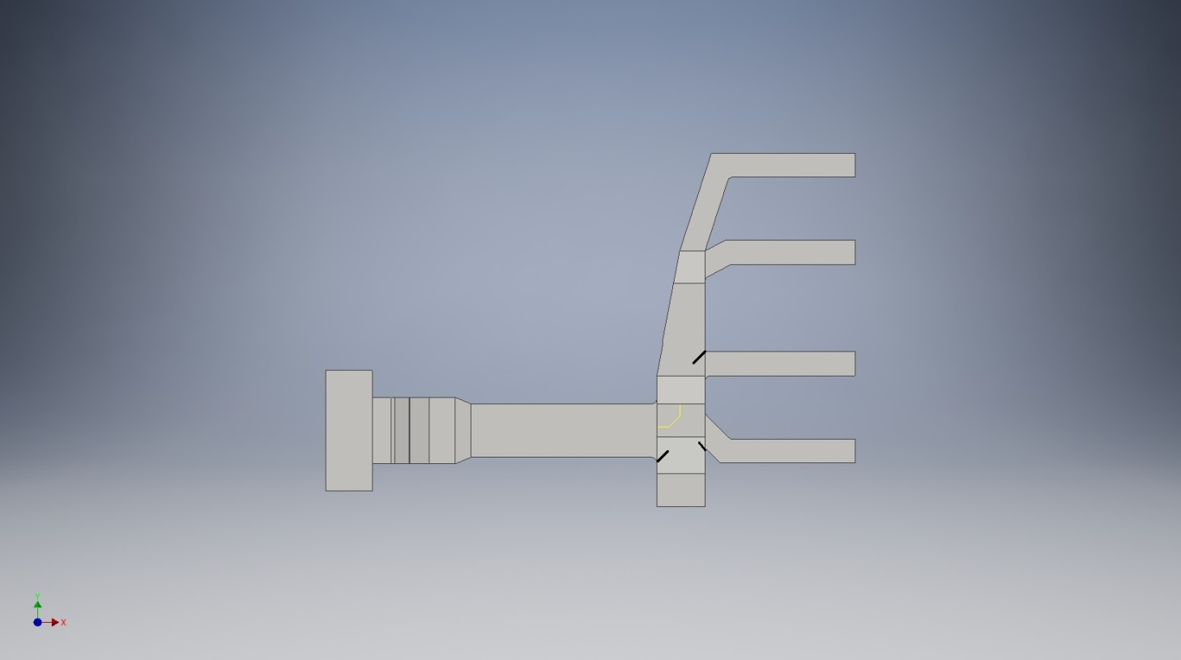

Fig 3.5 3D model of Duct with Guide Plate at the angles Ө1=45°, Ө2 =145°, Ө3=135°

The 3D model for base duct with Guide Plate with 3D model of Duct with Guide Plates at angle of Guide Plate at the angles Ө1=45°,Ө2 =145°, Ө3=135° are added is shown in Fig 3.5. The size of Guide plates Cannot Vary but angles are vary. The flow of flue gas will be maximum atoutlet zones 1 and 2 whereas Outlet zones 3 and 4 are minimized.

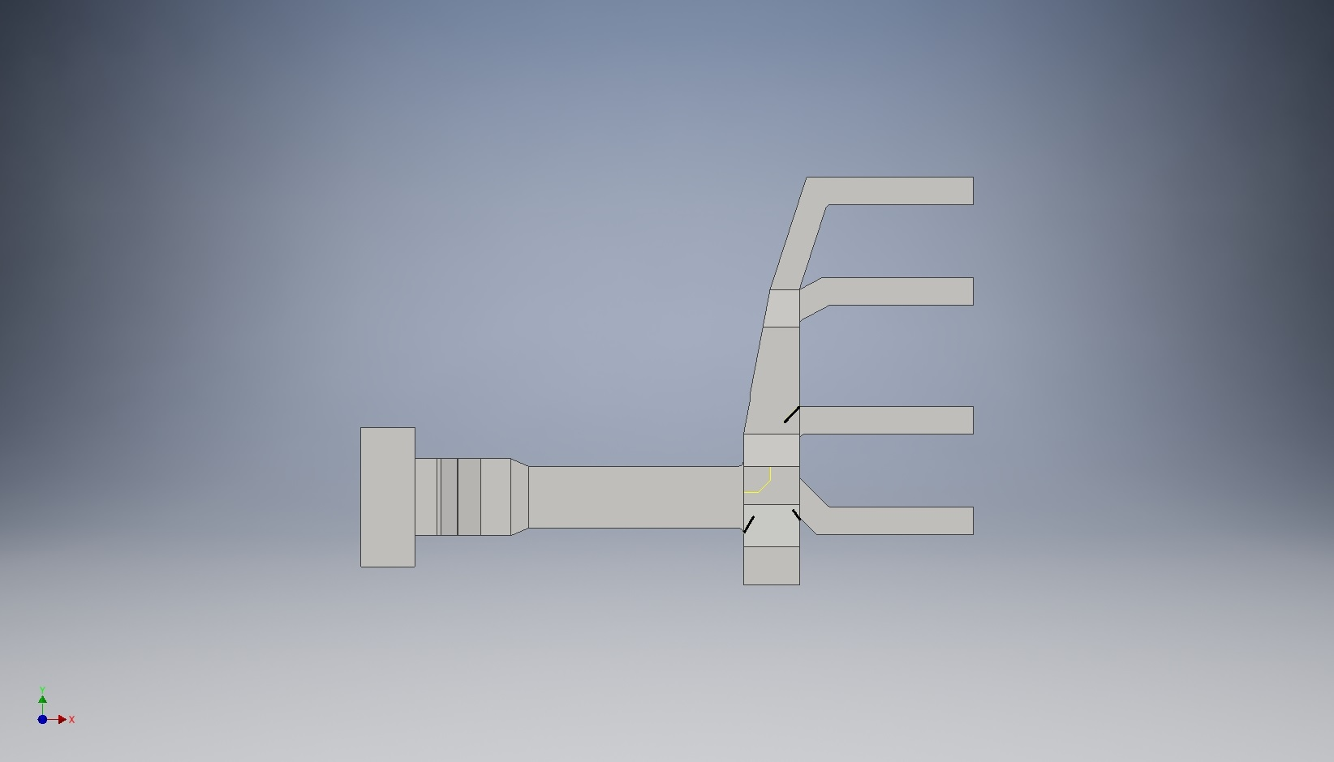

Fig 3.6 3D model of Duct with Guide Plate at the angles Ө1=60°, Ө2 =145°, Ө3=135°

The 3D model for base duct with Guide Plate with 3D model of Duct with Guide Plates at angle of Guide Plate at the angles Ө1=60°,Ө2 =145°, Ө3=135° are added is shown in Fig 3.6. The size of Guide plates Cannot Vary but angles are vary as same as Fig 3.5. The flow of flue gas will be maximum atoutlet zones 1 and 2 whereas Outlet zones 3 and 4 are minimized as same as Fig 3.5 and also flow of flue gas is slow.

**3.5 Geometrical calculation of 3D model duct**

**Inlet Duct**

Length of the inlet zone (l) = 15.748 m

Width of the inlet zone (b) = 6.109m

Mass Flow rate at inlet Zone () = 2703 tonnes/hr

= () = 375.42 kg/s

Flow rate at inlet zone ( = = 434 m3/s (Since ρ = 0.865kg/m3

Area of Inlet zone () = = 96.2m

Perimeter of Inlet zone () = =43.714m

Hydraulic Diameter at Inlet zone () = = = 8.80 m

Inlet Velocity () = = = 4.5114m/s

**Outlet Ducts 1-4:**

For Duct 1-4,

Length of the outlet zone (l) = 3.15 m

Width of the outlet zone (b) = 3.1m

Area of Outlet zone () =

= 9.765m

Perimeter of outlet zone () = = 12.5m

Hydraulic Diameter at outlet zone () = = = 8.80 m

Outlet Velocity () = = = 11.12 m/s

Mass Flow rate at outlet zone () = (Qo *ρ)= 108.5 * 0.865

= 93.852 kg/s

Flow rate at Outlet zone ( = = 108.5 m3/s

**Guide vane 1:**

Arc Diameter (Darc) = 7.6mm

Length of extrusion (L) =10mm

**Guide vane 2:**

Area of vane 2 (A) = 1600*1980*1600mm

Length of extrusion (L) =10mm

**Guide Plate 1:**

Length of Guide Plate (L1) = 2000mm

**Guide Plate 2:**

Length of Guide Plate (L2) = 1250mm

**Guide Plate 3:**

Length of Guide Plate (L3) = 2250mm

**3.6 Mesh Generation and Boundary Conditions**

Due to the symmetry in geometry, full 3D model ducts are considered for simulation. It contains 3 cases viz., Duct without guide vanes, with guide vanes, with guide plates. The meshing has been done in a GAMBIT 2.4.6 by setting as 150mm size of edges and 300mm size of faces and volume in Fig 3.7. Later on the Meshing has been exported to the ANSYS FLUENT 14 as Mesh and the scaling has been done from millimetre to meter. The mesh has been displayed by setting the edges in mesh section and outline as edge type as outline for visibility of Inlet parts. In models k-ε turbulence equation has been set for viscous effects. Due to the use of flue gas as working media, the properties of flue gas has been set such as ρ=0.865kg/m3,µ=2.145 x 10e-5kg/m-s. The name of material is set as Flue gas. The boundary conditions are set in the fluent as shown in Table 3.1

Table 3.1 BOUNDARY CONDITIONS FOR DUCTING SYSTEM

|  |  |
| --- | --- |
| Inlet | Velocity – inlet |
| Outlet (1-4) | Pressure Outlet |
| Symmetry | Symmetry |
| Guide Vanes | Wall |
| Guide Plate | Wall |

The velocity is set as 4.5m/s for inlet zone. The hydraulic diameter for inlet zone as 8.8m. The pressure at outlet is set as 0 Pa and its hydraulic diameter is 3.12m.

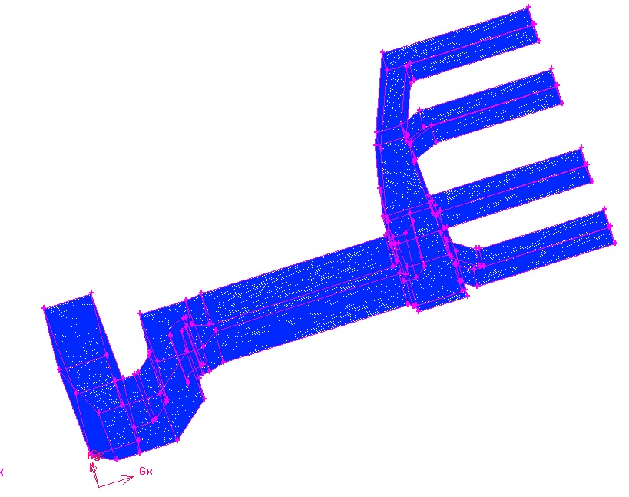

Fig 3.7 Meshing of 3D duct in Gambit

In Solution method, the scheme of Semi-Implicit Method for pressure linked Equations (SIMPLE) is followed for pressure velocity coupling gradient is set as Least Square Cell based. Pressure is set as Standard Pressure and momentum is set as Second Order Upwind because of its combination of accuracy and stability which interpolates the variable on the surface of the control volume. The scale of residuals has been set as 1e-03 for continuity, momentum and turbulence quantities. The solution has been initialized by setting compute from all zones. The calculations has been done by running for 100 iterations for initial results and 1000 iterations for Convergence results. The iso-surfaces has been created as: x-4.625, y-7.87, z-11.3 for viewing Pressure and velocity counters. Same procedure has been set for three iterations for making equal flow of a flue gas in outlets. The results for pressure and velocity has been computed.

**3**.**7 Analysis of Velocity Zones:**

The high velocity zone has been analysed by setting zone velocity from 18m/s to 30m/s. The low velocity zones has been analysed by setting velocity from 0 to 4m/s. In high velocity zones, there is some erosion occurs due to high pressure flow of hot flue gas or ash will flow to atmosphere. In low velocity zones, Ash will deposit in the ducts.

**CHAPTER 4**

**RESULTS AND DISCUSSION**

Now the pressure and velocity contours along with percentage deviations of mass flow rate, Average pressure and velocity has been analysed for five cases including Base case, Base case with guide vanes and Guide Plate Varying the angles.

**4.1 Actual duct System**

Fig 4.1 and Fig 4.2 shows the contours of Static Pressure and static velocity for the proposed duct. The pressure is increased at inlet when the coal is dropped and it gradually decreases when it becomes ash and flue gas at outlet. The velocity is lower at the inlet and it gradually increases at outlet according to flow of flue gas. This shows the flow is maximum in all zones due to equal supply of flow in outlet ducts.

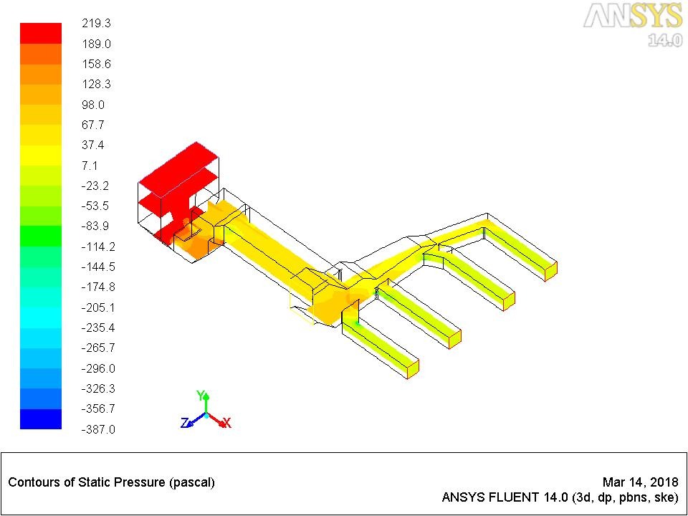

Fig 4.1.Contours of Static Pressure for base duct

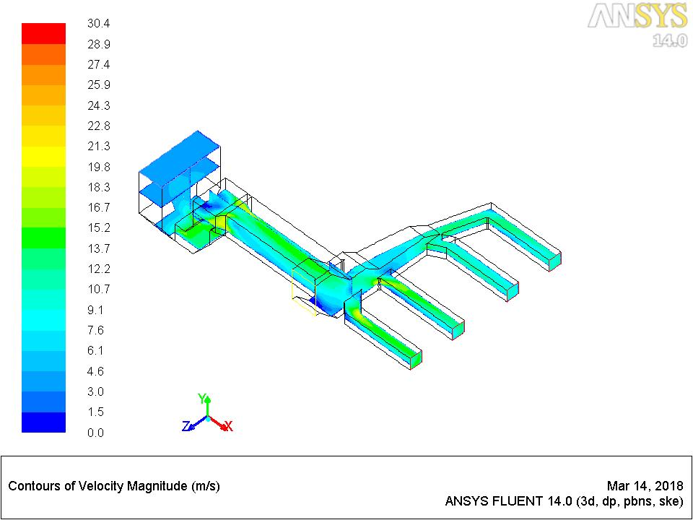

Fig 4.2.Contours of Velocity magnitude for base duct

Fig 4.3 and Fig 4.4 shows high velocity zones and low velocity zones for base duct. The high velocity zones are formed in the corners of duct from inlet zone and to the entry of outlet zones. This is the cause of erosion occurs in the duct due to high pressure. This is the cause of erosion occurs in the duct due to high pressure. Low velocity zones are formed due to deposition of ash in the ducts at low velocity inlet and symmetry zones and slightly in outlet zones.

The high velocity zones has been set from 18m/s to 30m/s because after 25m/s the duct gets eroded. The low velocity zones has been set because there is chance of ash deposition and also the flue gas may flow slowly.

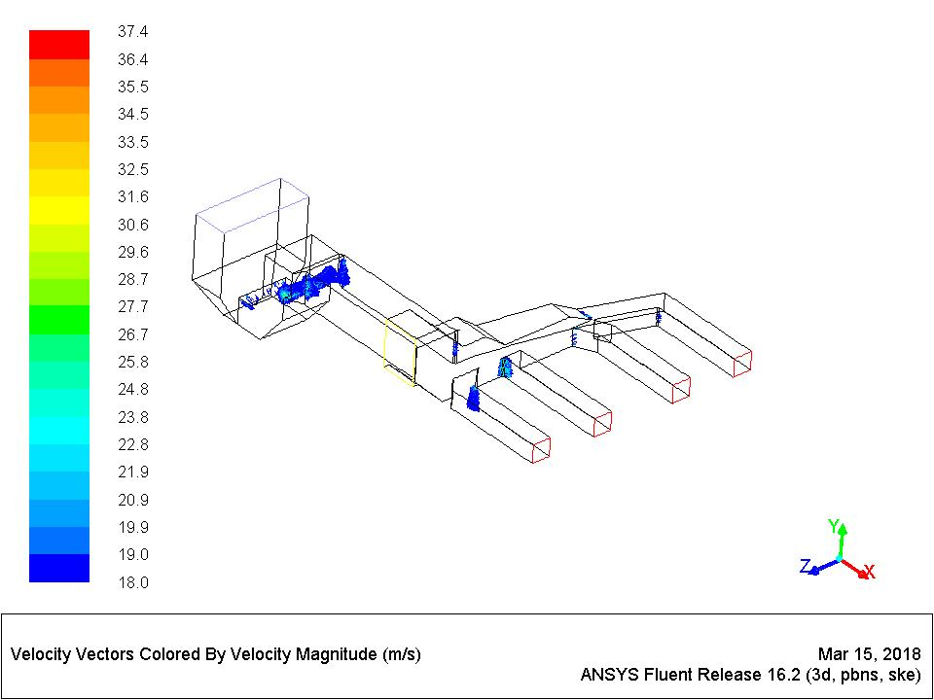

Fig 4.3 High velocity zones in Base duct

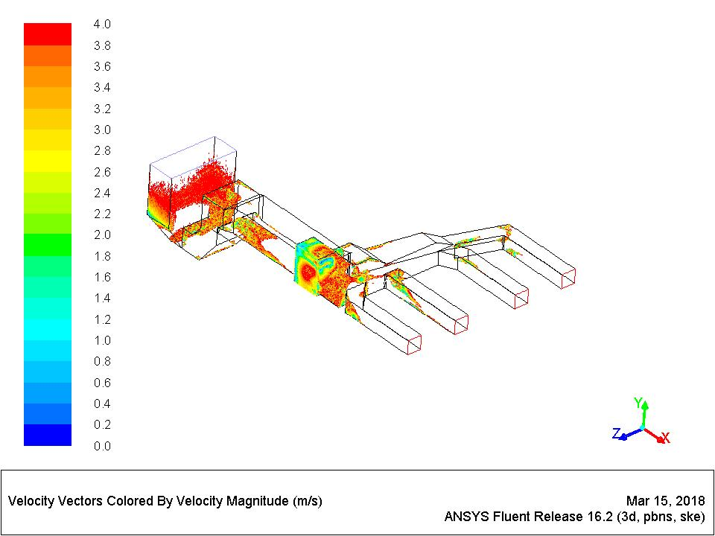

Fig 4.4 Low Velocity Zones in Base duct

**4.2 Ducting System with Guide vanes**

Pressure and Velocity contours of a ducting system with guide vanes as shown in Fig 4.5 and Fig 4.6 shows the pressure and velocity contours of duct with Guide Vanes. When the coal is dropped in inlet zone, the pressure is high and decreases gradually when the coal turns into ash and flue gas than exhausted at outlet. The guide vanes are fixed to obstruct the flow or to bring equal flow in all four outlet zones. In the velocity Contours, the velocity is lower in the inlet zone and raises gradually when the flue gas is passed to outlet zone. The flow of flue gas is obstructed by placing guide vanes. So, the flow is supplied equal in 4 outlet ducts.

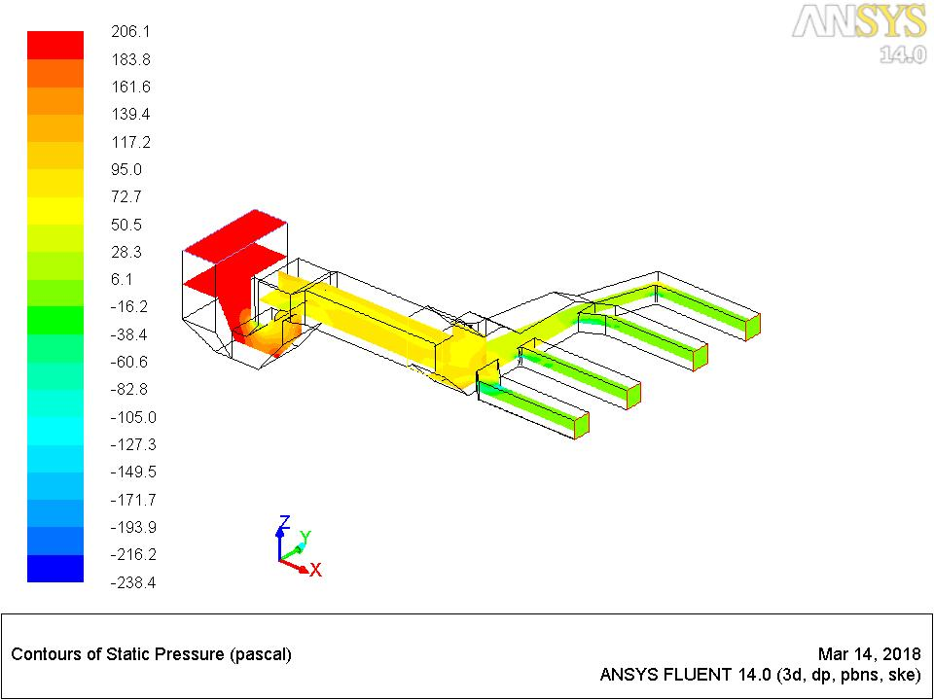  
 Fig 4.5 Pressure Contours of Duct with Guide vanes

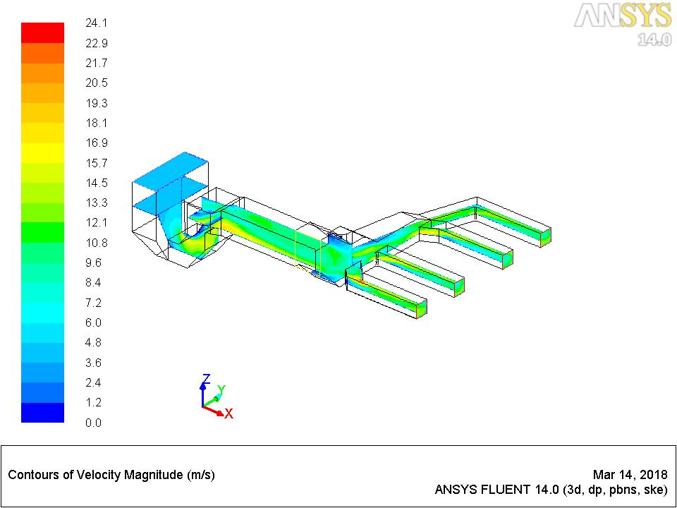

Fig 4.6 Velocity Contours of Duct with Guide vanes

Fig 4.7 and Fig 4.8 shows the high velocity and low velocity zones of a duct with guide vanes. The high velocity zones are occurs in the corners of the guide vanes and also in between the inlet and flow path of the ducts and also appears more in outlet zone corners. Guide vanes are applied for prevention of erosion in walls of ducts. In Low velocity zone, ash may deposit in inlet zone, on the guide vanes and outlet zones. The flue gases are deposited from of the ducts inlet to outlet through flow branches and also in symmetry. The flow is supplied equally to outlet planes by placing guide vanes.

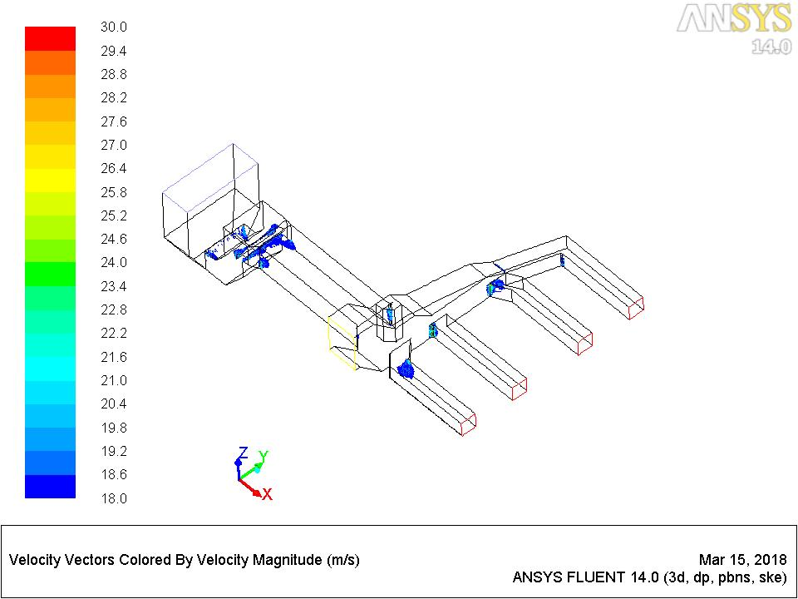

Fig 4.7 High Velocity Zones of duct with guide vanes

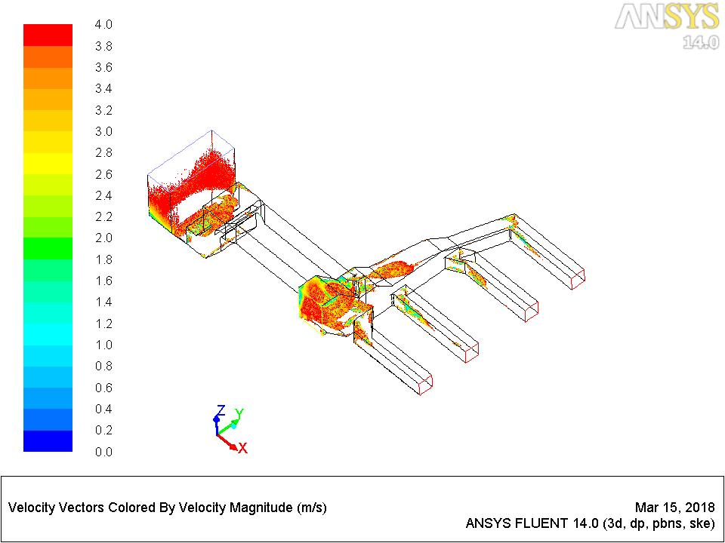

Fig 4.8 Low Velocity Zones of duct with guide vanes

**4.3 Ducting System with Guide Plate according to angle variation by NG method**

Fig 4.9 and Fig 4.10 shows the pressure and velocity contours of the ducts with guide plates at an angle Ө1=45°, Ө2 =135°, Ө3=155°.It is the guide plate can be placed for bringing equal flow in all ducts. The pressure drop may be slightly increased. The velocity is less in the inlet zone and slightly increases in the outlet zone. The equal flow of flue gas in four outlet pipes is set by attachment of guide vanes and also chamfering at the branch near the inlet zone. The flow of flue gas is obstructed by placing guide vanes. So, the flue gas is supplied equally in 4 outlet ducts.

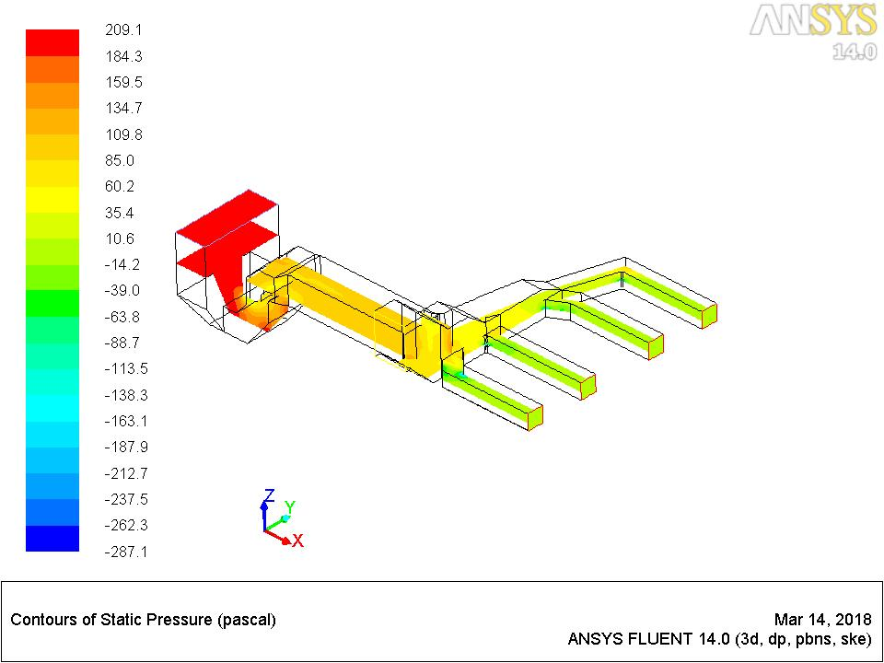

Fig 4.9 Pressure Contours of Duct with Guide Plate at the angles Ө1=45°,Ө2 =135°, Ө3=155°

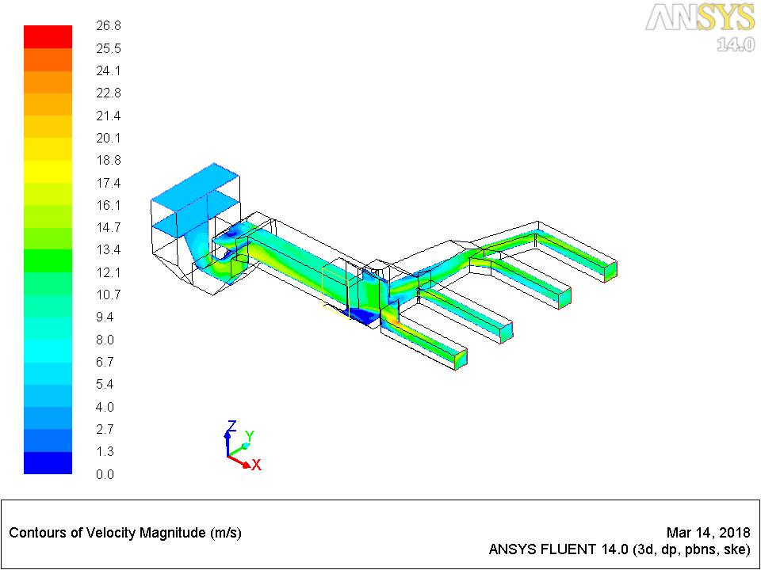

Fig 4.10 Velocity Contours of Duct with Guide Plate at the angles Ө1=45°,Ө2 =135°, Ө3=155°

In Fig 4.11 and Fig 4.12 shows the arise of high velocity and low velocity zones. In high velocity zones the erosion has stopped to occur by placing a guide Plates according to angle variation whereas in low velocity zones the flow of flue gas is equal in all zones.

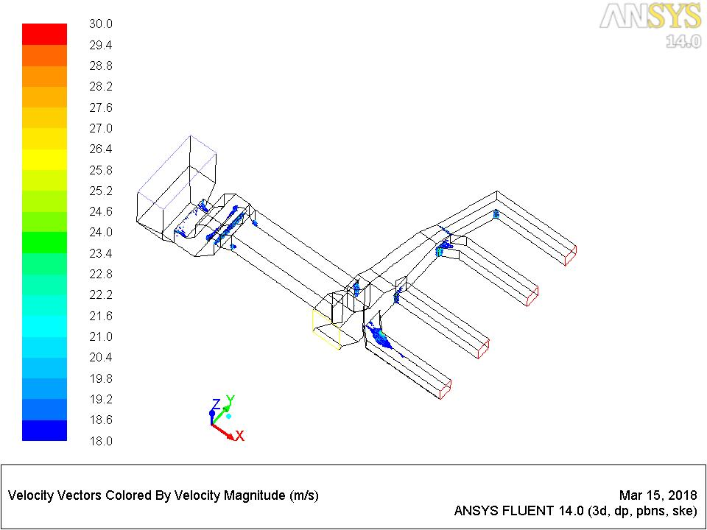

Fig 4.11 High Velocity Zone at the angles Ө1=45°,Ө2 =135°, Ө3=155°

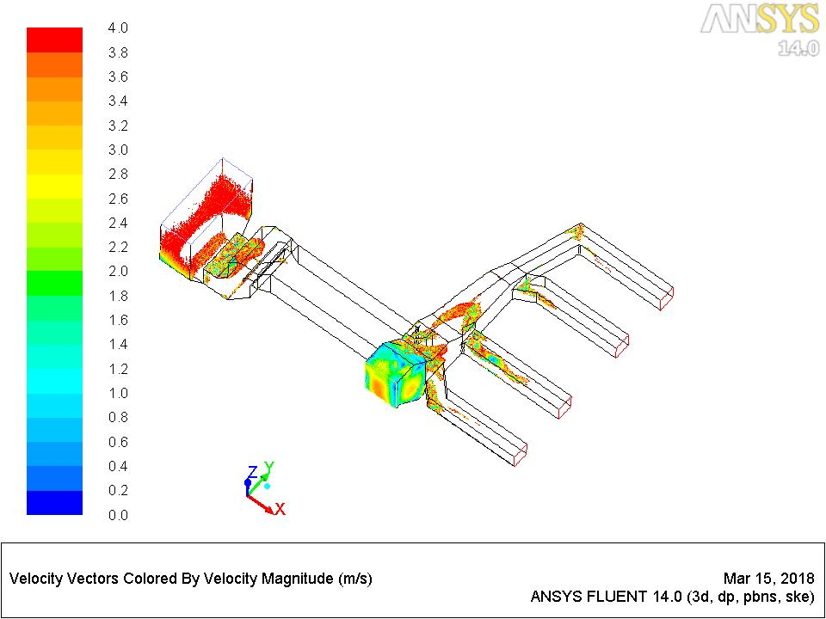

Fig 4.12 Low Velocity Zone at the angles Ө1=45°, Ө2 =135°, Ө3=155°

Fig 4.13 and Fig 4.14 shows the pressure and velocity contours of the ducts with guide plates at an angle Ө1=45°, Ө2 =145°, Ө3=135°. In Fig 4.17 same has been happened but pressure get decreases according to the variation in Guide plate angle. The velocity increases step by step according to the variation of guide plate angles is shown in Fig 4.18. The flow of flue gas is obstructed and made equal by placing guide vanes. The maximum flow of flue gas to outlet zone 1, 2 and minimum in Outlet zone 3, 4 by varying angles.

The same has been occurred in the pressure and velocity contours of the ducts with guide plates at an angle Ө1=60°, Ө2 =145°, Ө3=135° which is shown in Fig 4.17 and Fig 4.18. So, the maximum flow of flue gas to outlet zone 1, 2 and minimum in Outlet zone 3,4 by varying angles.

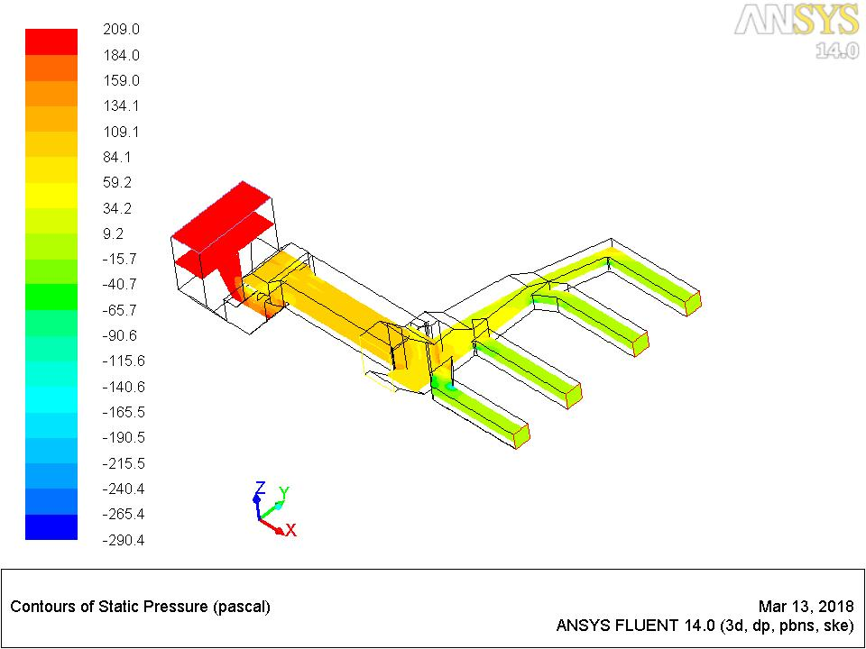

Fig 4.13 Pressure contours of the ducts with guide plates at an angle Ө1=45°, Ө2 =145°, Ө3=135°

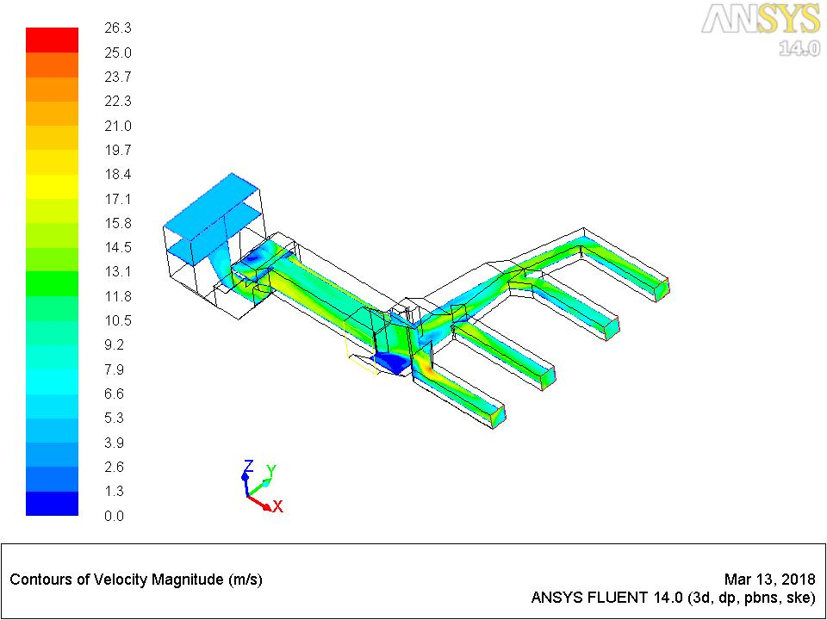

Fig 4.14 Velocity contours of the ducts with guide plates at an angle Ө1=45°, Ө2 =145°, Ө3=135°

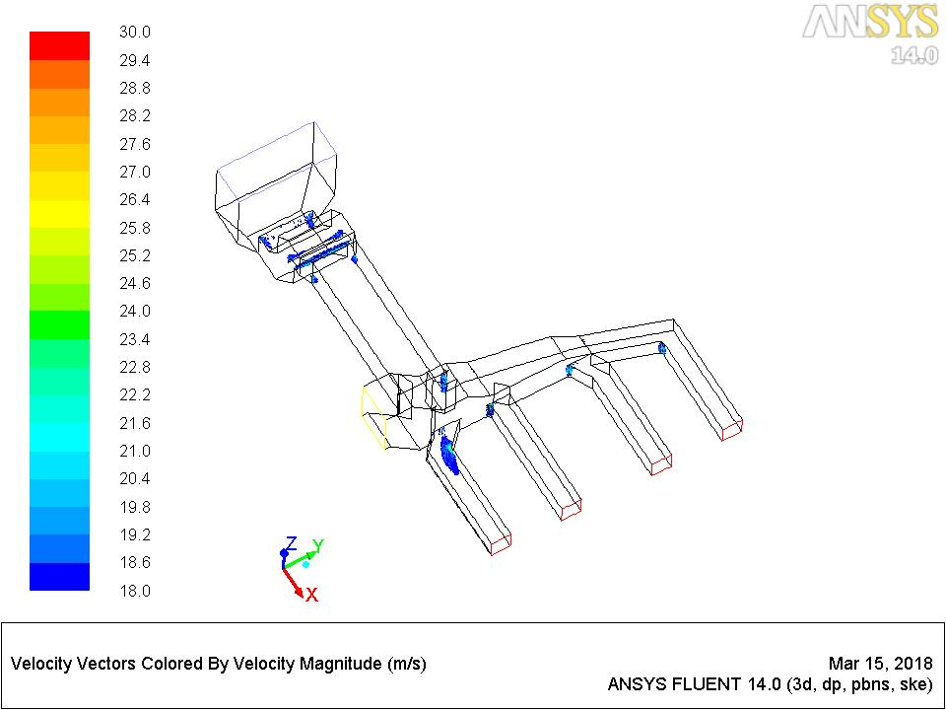

Fig 4.15 High Velocity Zone with guide plates at an angle Ө1=45°, Ө2 =145°, Ө3=135°

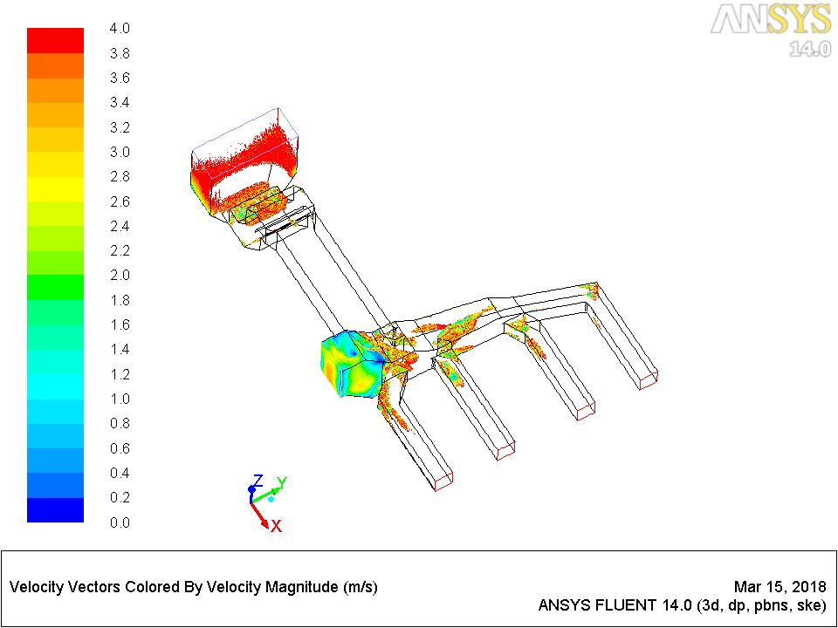

Fig 4.16 Low velocity zone with guide plates at an angle Ө1=45°, Ө2 =145°, Ө3=135°

Fig 4.15 and Fig 4.16 are the high velocity and low velocity zones of case with guide plate at an angle Ө1=45°, Ө2 =145°, Ө3=135°. The high velocity zones of outlet with Guide plates at case (ii) is decreased by changing the angle of Guide plate compared to sub case (i). In the low velocity zone, the flow of flue gas is slightly increased.

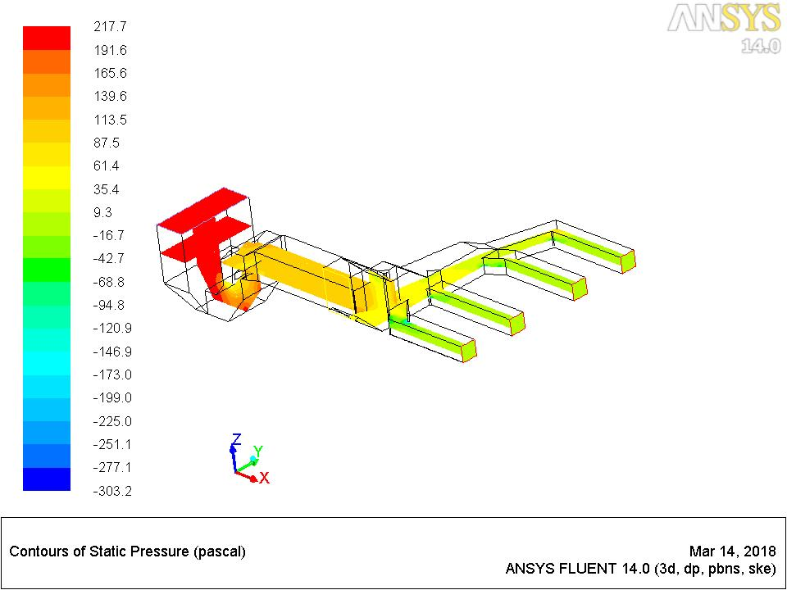

Fig 4.17.Pressure contours of the ducts with guide plates at an angle Ө1=60°, Ө2 =145°, Ө3=135°

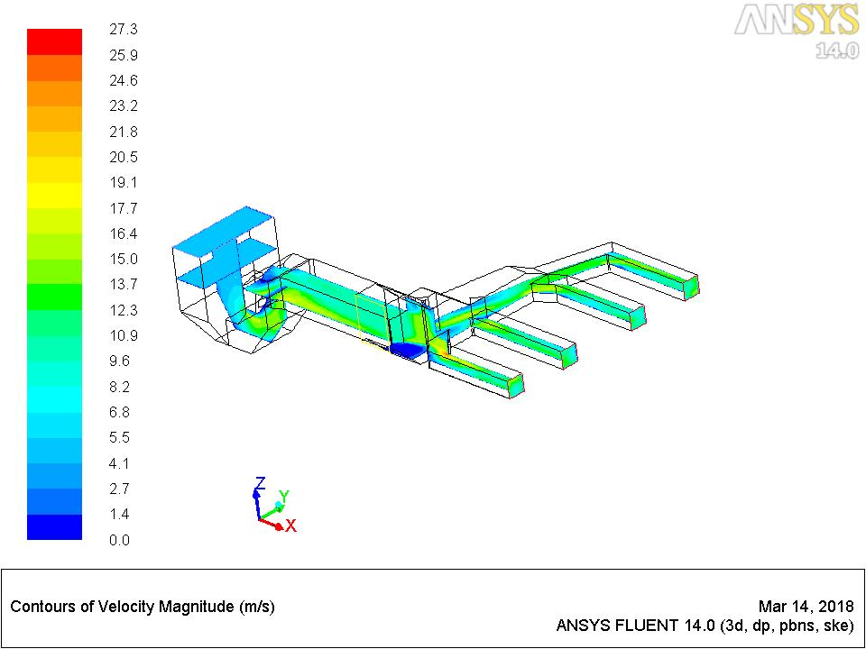

Fig 4.18 Velocity contours of the ducts with guide plates at an angle Ө1=60°,Ө2 =145°, Ө3=135°

The same has been occurs in high velocity and low velocity zones of duct with guide plate at their angles Ө1=60°, Ө2 =145°, Ө3=135° which is shown in Fig 4.19 and Fig 4.20.

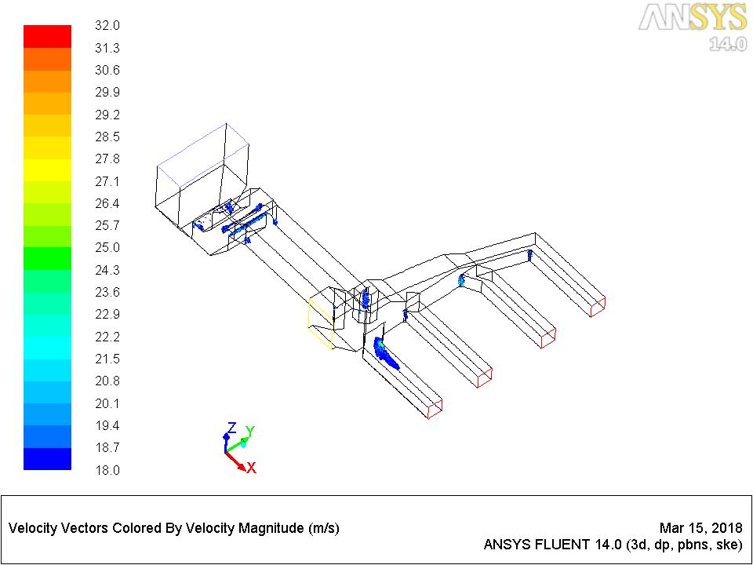

Fig 4.19 High Velocity Zone at an angle Ө1=60°, Ө2 =145°, Ө3=135°

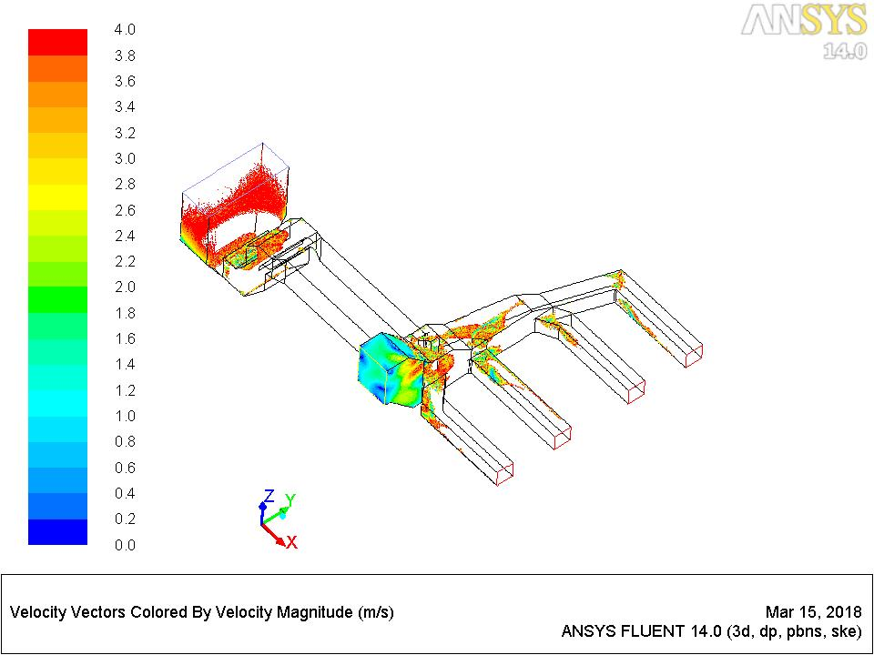

Fig 4.20 Low Velocity Zone at an angle Ө1=60°,Ө2 =145°, Ө3=135°

**4.4 Analysis of Variation in Percentage Deviation of Mass flow rate**

The table 4.1 shows the variation of % deviation in mass flow rate. There is a progressive reduction in all streams in case of base case without GV, case with guide vanes and guide plate shows improvement due to optimization. The angle simulation of these three cases has been done using NG method. Negative deviation in mass flow rate occurs because it is less than average Mass flow rate of the Outlet zone whereas Positive deviation occurs because it is higher than average mass Flow rate in Outlet Zone. Square deviation error in Percentage deviation in Base case without Guide Vane is more than all other cases.

Table 4.1 ANALYSIS IN % DEVIATION OF MASS FLOW RATE

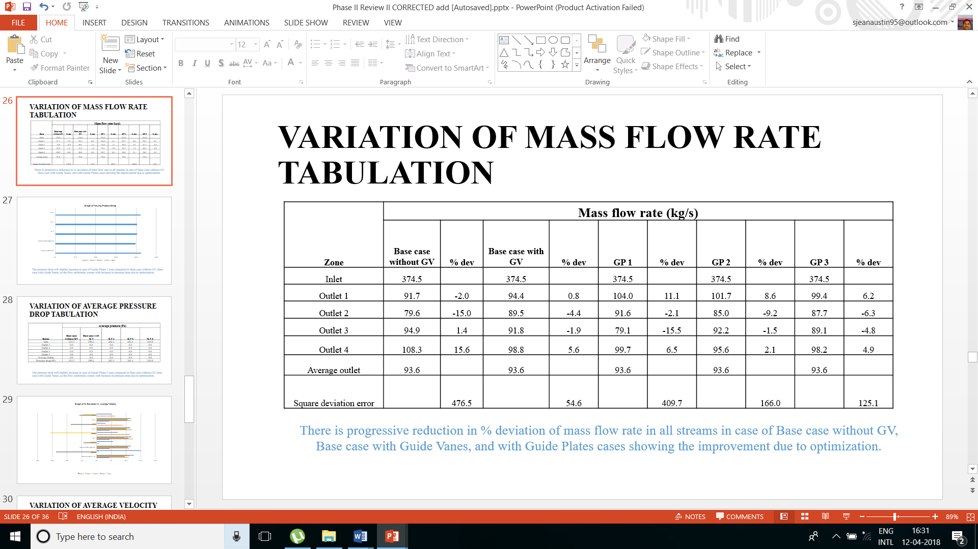

The graphical Comparison of % deviation of mass flow rate is shown in Fig 4.21. The mass flow rate at inlet zone is same in the inlet for all five cases but the mass flow rate variation in outlet zone of the duct.

Fig 4.21 Graph of % deviation Vs Mass flow rate

Fig 4.22 shows the variation of Pressure drop in all zones such as inlet and outlet zones 1-4.In the inlet zone, Pressure drop increases according to all the cases. The pressure at the inlet zone in GP 3 duct is slightly increased when compared to all other cases as uniformly comes with increase in pressure drop due to optimization but in outlet zones the pressure is obtained as zero due to equal flow.

**4.5 Analysis of Variation in Pressure Drop**

Fig 4.22 Graph of variation in Pressure drop

In Table 4.2 same as in Fig 4.22, the inlet pressure is increased in the base case (duct) without guide vanes increases rather than the other cases and also the pressure drop raises the same.

Table 4.2 ANALYSIS OF PRESSURE DROP IN EACH ZONE Vs EACH CASES

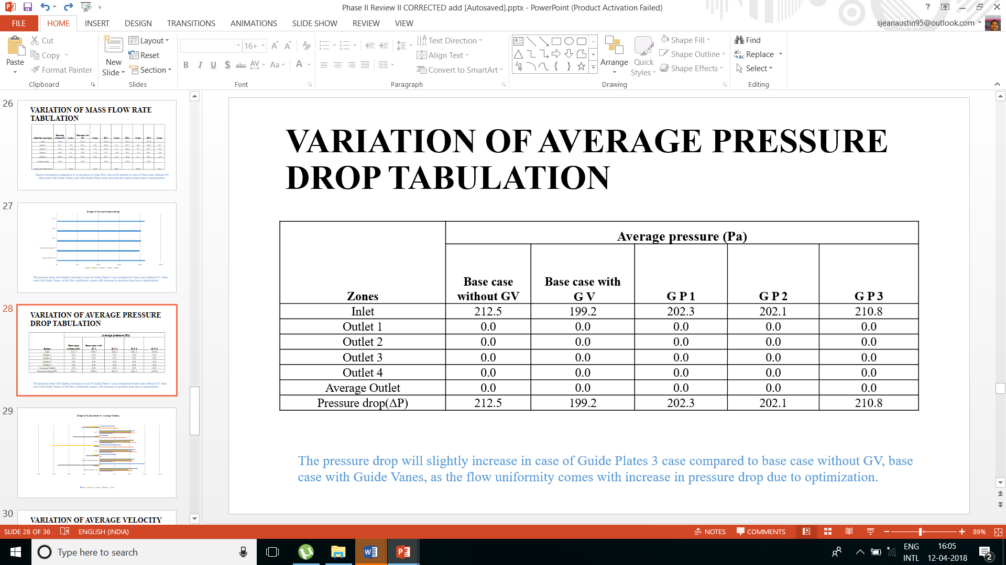

**4.6 Analysis of Variation in Percentage Deviation of Velocity**

Fig 4.23 shows the Graphical comparison of % deviation of velocity in each cases. There is a progressive reduction in % deviation in all cases and velocity increases.

Fig 4.23 Graph of % deviation in Average velocity

The variation of velocity and its deviation is shown in the Table 4.3.Here, the deviation of velocity in each cases contains negative values. Negative deviation in velocity occurs because it is less than average velocity of the Outlet zone whereas Positive deviation occurs because it is higher than average velocity in Outlet Zone. Square deviation error in Percentage deviation in Base case without Guide Vane is more than all other cases.

Table 4.3 ANALYSIS OF % DEVIATION IN VELOCITY

|  |  |  |  |  |  |  |  |  |  |  |
| --- | --- | --- | --- | --- | --- | --- | --- | --- | --- | --- |
| **Zone** | **Average velocity (m/s)** | | | | | | | | | |
| **Base case** | **% dev** | **Base case with GV** | **% dev** | **G P 1** | **% dev** | **G P 2** | **% dev** | **G P 3** | **% dev** |
| Inlet | 4.5 | 0 | 4.5 | 0 | 4.5 | 0 | 4.5 | 0 | 4.5 | 0 |
| Outlet 1 | 10.9 | -2.0 | 11.2 | 0.9 | 12.4 | 11.4 | 12.1 | 8.9 | 11.8 | 6.4 |
| Outlet 2 | 9.6 | -13.8 | 10.6 | -4.4 | 10.9 | -1.8 | 10.2 | -8.7 | 10.5 | -5.8 |
| Outlet 3 | 11.3 | 0.9 | 10.9 | -2.1 | 9.4 | -15.5 | 11.0 | -1.3 | 10.6 | -4.6 |
| Outlet 4 | 12.8 | 14.9 | 11.8 | 5.6 | 11.9 | 7.1 | 11.5 | 3.0 | 11.7 | 5.2 |

**4.7 Analysis of Percentage Deviation in flow rates in ESP streams**

Fig 4.24 shows graphical comparison of % deviation of flow rates in ESP streams. This shows the deviations in outlet zones 1-4 with the cases of angle variation of guide plates.

Fig 4.24 Graph of % deviation of flow rates in ESP streams

Table 4.4 ANALYSIS OF % DEVIATION OF FLOW RATES IN ESP STREAMS

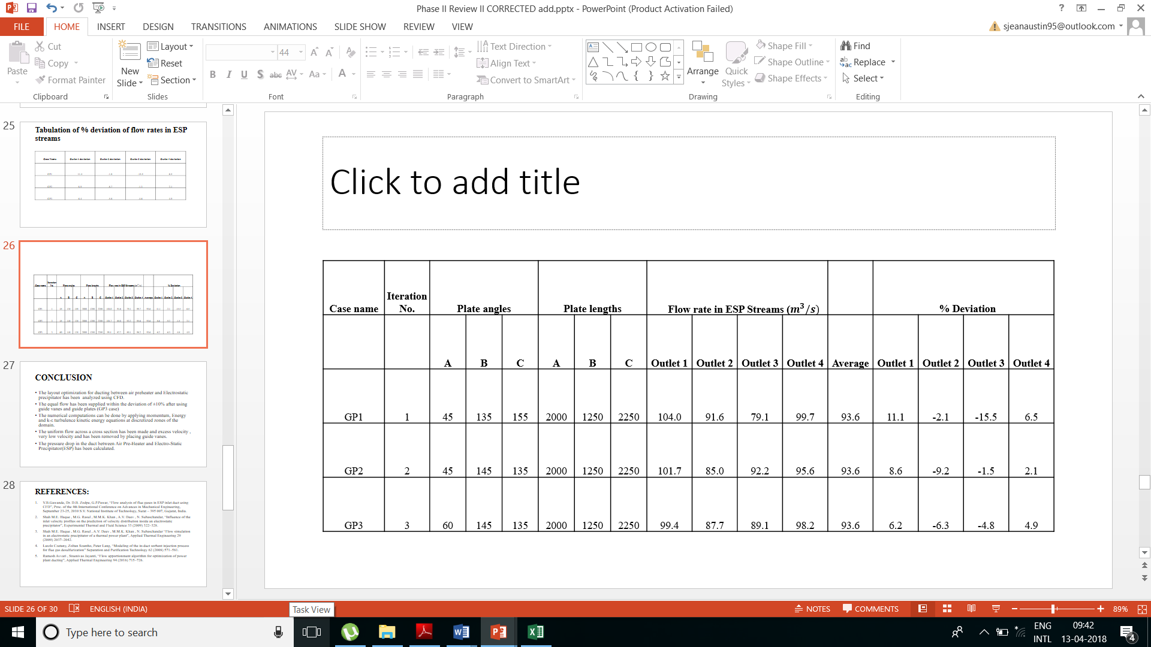

In outlet zones for three cases of Guide plate angle variation, the deviation of flow increases at the positive values along with comparison of outlet deviations of duct along with angle varied Guide Plates is shown in Table 5. In outlet zones for three cases of Guide plate angle variation, the deviation of flow increases at the positive values. The deviation of outlet 1 increases than the outlet 4 whereas the % deviation of outlet 2 and 3 decreases. The Outlet 2 and 3 has negative values and outlet 1-and 4 has positive values. Hence all the above cases showing improvement due to optimization.

**CHAPTER 5**

**CONCLUSION**

* The layout optimization for ducting between air preheater and Electrostatic precipitator has been analyzed using CFD.
* The equal flow has been supplied within the deviation of ±10% after using guide vanes and guide plates (GP3 case).
* The numerical computations can be done by applying Continuity, Momentum, Energy and k-ε turbulence kinetic energy equations at discretized zones of the domain.
* The uniform flow across a cross section has been made and excess velocity, very low velocity and has been removed by placing guide vanes.
* The pressure drop in the duct between Air Pre-Heater and Electro-Static Precipitator (ESP) has been calculated.

**REFERENCES**

1. V.B.Gawande, Dr. D.B. Zodpe, G.P.Pawar, “Flow analysis of flue gases in ESP inlet duct using CFD”, Proc. of the 4th International Conference on Advances in Mechanical Engineering, September 23-25, 2010 S.V. National Institute of Technology, Surat – 395 007, Gujarat, India.
2. Shah M.E. Haque , M.G. Rasul , M.M.K. Khan , A.V. Deev , N. Subaschandar, “Influence of the inlet velocity profiles on the prediction of velocity distribution inside an electrostatic precipitator”, Experimental Thermal and Fluid Science 33 (2009) 322–328.
3. Shah M.E. Haque , M.G. Rasul , A.V. Deev , M.M.K. Khan , N. Subaschandar “Flow simulation in an electrostatic precipitator of a thermal power plant”, Applied Thermal Engineering 29 (2009) 2037–2042.
4. Laszlo Czetany, Zoltan Szantho, Peter Lang, “Modelling of the in-duct sorbent injection process for flue gas desulfurization” Separation and Purification Technology 62 (2008) 571–581.
5. Ramesh Avvari, Sreenivas Jayanti, “Flow apportionment algorithm for optimization of power plant ducting”, Applied Thermal Engineering 94 (2016) 715–726.
6. Ramesh Avvari, Sreenivas Jayanthi, “Heuristic shape optimization of gas ducting in process and power plants” Chemical Engineering research and design 91 (2013) 999-1008.
7. C. Bhasker, “Flow simulation in Electro-Static-Precipitator (ESP) ducts with turning vanes” Advances in Engineering Software 42 (2011) 501–512.
8. A.S.M.Sayema, M.M.K. Khana, M.G. Rasula, M.T.O. Amanullahb, N.M.S.Hassan “Effects of baffles on flow distribution in an electrostatic precipitator (ESP) of a coal based power plant”, Journal of Procedia Engineering 105 ( 2015 ) 529 – 536.
9. Madhulika Singh, Shah Alam, “CFD Approach to Design and Optimization of Air, Flue Gas Ducting System”, International Journal of Advance Engineering and Research Development Volume 2, Issue 5, May -2015.
10. Luca Marocco, Alessandro Mora, “CFD modelling of the Dry-Sorbent-Injection process for flue gas desulfurization using hydrated lime”, Separation and Purification Technology 108 (2013) 205–214.
11. Laszlo Czetany , Zoltan Szantho, Peter Lang, “Rectangular supply ducts with varying cross section providing uniform air distribution”, Applied Thermal Engineering 115 (2017) 141–151.
12. .J.L. Ferrín, L. Saavedra , “Distribution of the coal flow in the mill-duct system of the As Pontes Power Plant using CFD modeling,” Fuel Processing Technology, volume 106, Pages 84-94, February 2013.
13. Bhutta M. M. A., Nasir H., Bashir M. H., Khan A. R., Ahmad K. N., Khan S., “CFD applications in various heat exchangers design”: A review Article, Applied Thermal Engineering, volume 32, Pages 1-12, January 2012.
14. O.C. Jones, “An improvement in the calculation of turbulent friction in rectangular ducts”, J. Fluids Eng. Trans. ASME 98 (2) (1976) 173–181.
15. Z. Duan, M.M. Yovanovich, Y.S. Muzychka, “Pressure drop for fully developed turbulent flow in circular and noncircular ducts”, J. Fluids Eng. 134 (6) (2012).
16. K. Park, C.H. Hong, J. Lee, J.K. Ahn, S.L. Park, “Flow control and optimal shape of head box using CFD and SMOGA”, International Journal of Aerospace and Mechanical Engineering 4 (3) (2010) 143–148.
17. H. Liu, P. Li, J.V. Lew, “CFD study of flow distribution uniformity in fuel distributors having multiple structural bifurcations of flow channels”, Int. J. Hydrogen Energy 35 (2010) 9186–9198.
18. J.C.K. Tong, E.M. Sparrow, J.P. Abraham, “Geometric strategies for attainment of identical outflows through all of the exit ports of a distribution manifold in a manifold system”, Applied Thermal Engineering 29 (2009) 3552–3560.
19. C.C. Wang, K.S. Yang, J.S. Tsai, I.Y. Chen, “Characteristics of flow distribution in compact parallel flow heat exchangers, part I: typical inlet header”, Appl. Therm. Eng. 31 (2011) 3226–3234.
20. Limin Wang, Yilin Fan, Lingai Luo, “Heuristic optimality criterion algorithm for shape design of fluid flow” Journal of Computational Physics 229 (2010) 8031–8044.